**Name**: Michael Samy Habachy Melad

**B.N**: 634

**Date**: 6/6/2021

**Topic**: Artificial Intelligence

**Application Brief:**

I chose this topic to serve humanity and the world because this artificial intelligence finds any solution to any problem that humans cannot solve and know.

It is very important in education so that we find that he gets a distinctive approach to education, as it helps the student to know the level he has, and also to obtain any program he requests, so we do not find that it does not affect the educational structure.

Rather, it is of great importance to it, as this helps the student a lot and cannot abandon him during his education in order to reach the desired success for him and to understand the most difficult things in education.

We find that artificial intelligence has a great importance in many fields such as agriculture, medicine, engineering and all areas of life.

We cannot imagine our life without the use of AI, it is very general in life, whatever it has its fears but we cannot control many things without it, so we have to understand this well and not make it equal to humans.

But it has its importance to help men only.

**Screenshots:**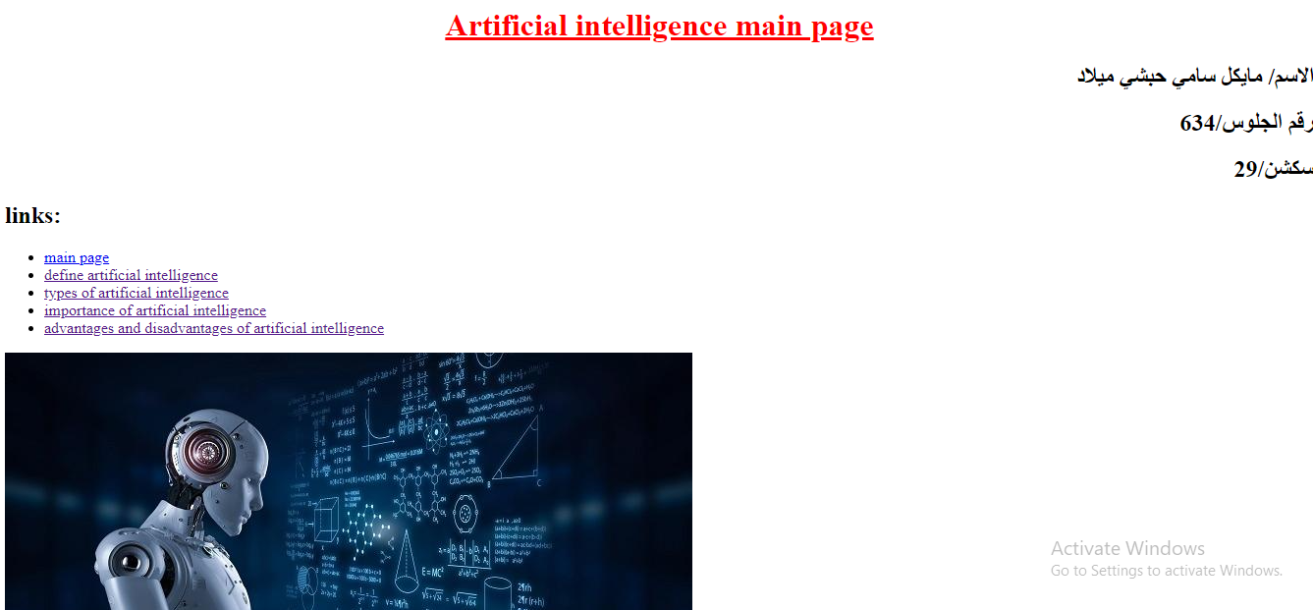

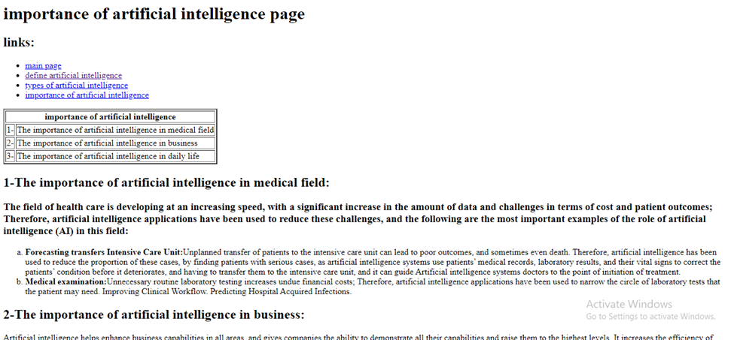

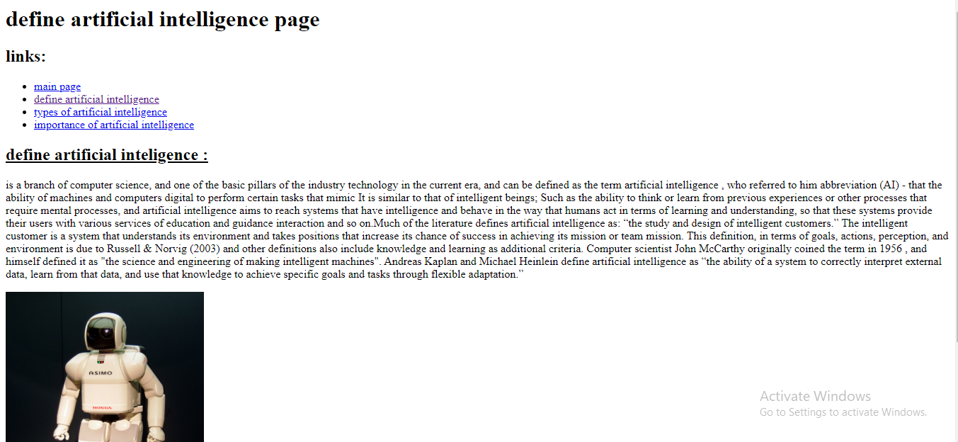

**Source code:**

